Details:
PSoC 4/5 comes with ARM Cortex processors which is a very flexible and powerful platform. All the projects for these devices are developed in PSoC Creator using embedded C and compiled using ARM GCC compiler which comes with PSoC Creator. GCC can also compile programs written for ARM devices in C++.
By following the steps given below, it is possible to tweak PSoC Creator to use and compile C++ source files.
Steps to be followed are:
- Create a new project for PSoC 5 or PSoC 4 device.
- Design the schematic of the project and build it.
- Add a header file which declares classes, its member functions and data members.
- Add a ‘C’ source file with the same name as the header which defines the member functions of the classes declared in the header file.
- Rename the ‘*.c’ file as ‘*.cpp’
- If you are accessing ‘C’ source files/ headers in the C++ source header files, add the following section to the C++ header/source file:
#ifdef __cplusplus
extern "C"{
#endif

#include <your_c_header_file.h>

#ifdef __cplusplus
}
#endif
- Add your C++ code to ‘main.c’ and Rename it as ‘main.cpp’
- Go to the project folder and open “*.cyprj” file in any text-editor. Find every “.cpp” file with line like the following in Figure 1 and change the build action from “NONE” to “C_FILE” as in Figure 2. After repeating this for every C++ source file, save the “*.cyprj” file and PSoC Creator should reload the file.

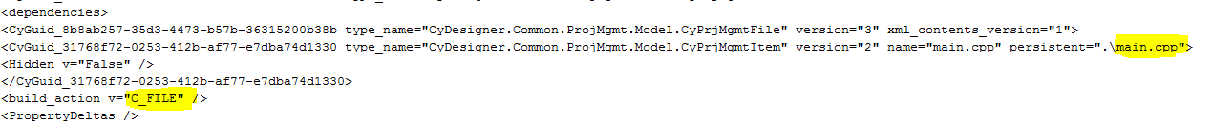

- To make PSoC Creator compile C++ code, some changes need to be made in the compiler settings. Open ‘Build Settings’ of the project and go to compiler list and add the following text in the ‘Command Line’:

-fno-rtti -funsigned-char -funsigned-bitfields -fpack-struct -fshort-enums

If you are using any source file/header file which is not there inside the project folder, add –l./(location of the source/header) in the command line.

- Build the project. The code shall build and compile if the code is error free.

LED_Blinky Project in C++:
Following these steps, I have made a LED_Blinky project for PSoC 4 which uses C++ classes and objects to start a counter to count at 1HZ, blink all the 3 LEDs on the pioneer kit successively after every 3 seconds and send the current counter value on the HyperTerminal. This project is attached with the memo.
Schematic of the project:
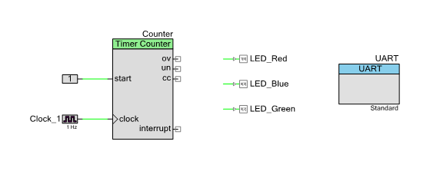
LED_Blinky.h Header File: Declare classes, its member functions and data members here
#ifndef LED_BLINKY_H
#define LED_BLINKY_H

#ifdef __cplusplus
extern "C"{
#endif

#include <device.h>
#ifdef __cplusplus
}
#endif

class LED
{

private:
static unsigned char count;

public:
void init(void);
void glow_LED(void);
void CounterValue(void);
void send_to_UART(void);

};

#endif
LED_Blinky.c source file: Define the member functions of the classes declared in the header file
#include <LED_Blinky.h>

void LED::init(void)
{
Counter_Start();
UART_Start();
}

unsigned char LED::count;

void LED::glow_LED(void)
{
if(count < 3)
{
LED_Red_Write(0);
LED_Green_Write(1);
LED_Blue_Write(1);
}
else if(count < 6)
{
LED_Red_Write(1);
LED_Green_Write(0);
LED_Blue_Write(1);
}
else
{
LED_Red_Write(1);
LED_Green_Write(1);
LED_Blue_Write(0);
}
}

void LED :: CounterValue(void)
{
count = Counter_ReadCounter();
}

void LED :: send_to_UART(void)
{
UART_UartPutChar(count + 48);
}

main.cpp:
#include <LED_Blinky.h>

int main()
{
LED blink;

blink.init();

for(;;)
{
/* Place your application code here. */
blink.CounterValue();
blink.glow_LED();
blink.send_to_UART();
}
}
Reference: Matt Durak’s white paper on porting Arduino Libraries to PSoC Creator.
http://www.egr.msu.edu/classes/ece480/capstone/fall11/group01/doc-6-notes-from-matt.pdf

